**Online Portal for Bidding between Farmers & Buyers**

DATABASE PROJECT REPORT

**SUBMITTED BY**

|  |  |
| --- | --- |
| **Name: Aditya Madhyasta** | **USN: 1MS18CS011** |
| **Name: Akash Jain** | **USN: 1MS18CS014** |
| **Name: Akshat Jaitly** | **USN: 1MS18CS015** |
| **Name: Anup Vernekar** | **USN: 1MS18CS021** |

As part of the Course **Database Systems– CS52**

SUPERVISED BY

Faculty

Aparna R

ASSISTANT PROFESSOR

DEPARTMENT OF CSE



DEPARTMENT OF COMPUTER SCIENCE AND ENGINEERING

RAMAIAH INSTITUTE OF TECHNOLOGY

Sept 2020 – Jan 2021

Department of Computer Science and Engineering

Ramaiah Institute of Technology

(Autonomous Institute, Affiliated to VTU)

Bangalore – 54

**CERTIFICATE**

This is to certify that **Name: Aditya Madhyasta (USN:1MS18CS011)**, **Name: Akash Jain (USN: 1MS18CS014), Name: Akshat Jaitly (USN: 1MS18CS015), Name: Anup Vernekar(USN: 1MS18CS021)** have completed the **“**Online Portal for Bidding between Farmers & Buyers**”** as part of Database Project. We declare that the entire content embodied in this B.E. 5th Semester report contents are not plagiarized.

Submitted by Guided by

|  |  |
| --- | --- |
| Name: Aditya Madhyasta | USN: 1MS18CS011 |
| Name: Akash Jain | USN: 1MS18CS014 |
| Name: Akshat Jaitly | USN: 1MS18CS015 |
| Name: Anup Vernekar | USN: 1MS18CS021 |

Aparna R

(Dept of CSE, RIT) (Assistant Professor, Dept. of CSE, RIT)

Department of Computer Science and Engineering

Ramaiah Institute of Technology

(Autonomous Institute, Affiliated to VTU)

Bangalore – 54

**Evaluation Sheet**

|  |  |  |  |  |  |
| --- | --- | --- | --- | --- | --- |
| **Sl. No** | **USN** | **Name** | **Research Content understanding**  **and Coding**  **(10)** | **Demo & Report submission**  **(10)** | **Total Marks**  **(20)** |
| **1** | 1MS18CS011 | Aditya Madhyasta |  |  |  |
| **2** | 1MS18CS014 | Akash Jain |  |  |  |
| **3** | 1MS18CS015 | Akash Jain |  |  |  |
| **4** | 1MS18CS021 | Anup Vernekar |  |  |  |

Evaluated By

(Aparna R)

Assistant Professor

Computer Science & Engineering, RIT

**CONTENTS**

|  |  |  |
| --- | --- | --- |
| **Sl. No.** | **TITLE** | **Page no** |
| **1.** | **Content’s Abstract** | 1 |
| **2.** | **Introduction** | 2 |
| **4.** | **Background, Motivation and Scope** | 3 |
| **5.** | **Methodology** | 4 |
| **7.** | **Requirements** | 5 |
| **8.** | **E-R Diagram** | 6 |
| **9.** | **Relational Database Design** | 7 |
| **10.** | **Database Normalization** | 8 |
| **11.** | **Data Directory** | 9 |
| **12.** | **Graphical User Interface** | 10 |
| **13.** | **Source Code** | 11 |
| **14.** | **Conclusion** | 12 |

**CONTENTS ABSTRACT**

#### India is the fourth largest agriculture sector in the world. Agriculture is the backbone of India, saying this, many of the agriculturists face so many difficulties and problems in agriculture that includes improper value of products they produce and there are no proper platforms which can help them to overcome these difficulties.

#### The project titled ‘Online Portal For bidding between Farmers and Buyers’ is a farmer management website application which helps the farmers to improve their productivity and profitability. The farmers can sell their productions online and the buyers can purchase various agricultural products they are interested in. Through this the farmers can get the best price for their products and the crops. This also eliminates the middlemen so that the farmers can get the complete benefit. Farmers can choose their customers who quote more, that is, they can choose whom to sell their product on the basis of price the customers are ready to pay for their products. Farmers get to know the demand in the market of the products they are selling. This can also help them to concentrate on the crops which is in high demand. The online bidding can help the farmers meet the customer directly.

**INTRODUCTION**

India is fourth largest agriculture sector in the world. Agriculture sector provides employment to over two third population of the country. Not only this, agriculture is major source of income for more than 75% Indians. Although agriculture is of great significance to the national economy yet the condition of Indian farmers and other individuals depended on the sector is unfortunate.

Online Portal for Bidding between Farmers & Buyers is to help farmers by providing all kinds agriculture related information in the website. This portal is farmer management website application which helps the farmers to get best prices for their production. It helps the farmers to improve their productivity and profitability. It enables farmers to sell their productions through online and the customers can bid their production based on their demand.

The online bidding between farmers and buyers Project provides its users to bid directly. This project is aimed at solving some of the major problems related to farmers. The web interface has been designed completely user friendly, to facilitate the access even to an illiterate farmer.

**BACKGROUND, MOTIVATION and SCOPE**

The project is aimed at solving some of the major problems related to farmers. The main objective of developing “Online Portal for Bidding between Farmers & Buyers” application is to help farmers by providing all kinds agriculture related information in the website. “Online Portal for Bidding between Farmers & Buyers” is farmer management website application which helps farmers to give best-practice farming processes. It helps farmers to improve their productivity and profitability. It enables farmers to sell their products online.

The scope of this project is that it makes farmers get the best price for their products. Eliminate middlemen so that the farmers get the total benefit. Farmers can choose their customers who quote more i.e., they can choose whom to sell their products on the basis of the price the customers are ready to pay. Farmers get to know the demand in the market of the products they are selling. This will help them to concentrate on the crops which is in high demand. The Online Bidding Application helps the farmers meet the customers directly. The winner of the bid and the seller of that product can make a deal.

The site helps the farmer management website application. This site helps the farmers to sell their agricultural produce online and suggests best in practice farming. Hence providing a wider market and helping them not restrict themselves to local market.

**METHODOLOGY**

a. The idea is to develop an online bidding application that would help the farmers and the customers contact each other directly and do the business.

b. This would include a database platform that would store the data of the registered users (farmers and customers).

c. The database will be used to store the data of registered customers and farmers (Platform as a Service).

d. The application will include module for registered farmers to participate in it.

e. Farmers get to know the actual demand in the market through the requests that customers post on the application.

f. This idea comes under Recent trends in IT and hence would require Model View Controller design pattern as the core technique to build it.

g. The application would help the farmers bid the price and the highest bidder (customer) will get away with the product.

h. This application can be made available to anyone across the globe via accessing the URL

**REQUIREMENTS**

The application needs to be able to facilitate buying and selling of goods and allow the sellers and buyers to communicate directly through the platform. All the components need to be interconnected and are powered by a single backend running on Node.js and MongoDB. The frontend is to be built using React JS. There are three major user facing components that are required to be built:

a. Admin Panel: The admin panel should allow the admin to easily access all the required features. The admin should be able to create new users, either farmer or buyer. The admin should also be able to delete previously created accounts if required.

b. Farmer UI: The frontend UI for farmers should consist of an easy way to create new products and list them for sale. The farmer should be able to view the current bids and also accept the bids. The farmer should also be allowed to reject the bids. They should also be able to easily delete their previously created products.

c. Buyer UI: The buyers should be provided with a simple UI to view all the products that are on available for purchase. The buyers should be provided with an option to view the current bid on a product. The buyers can also place new bids to purchase the product.

**E-R DIAGRAM**

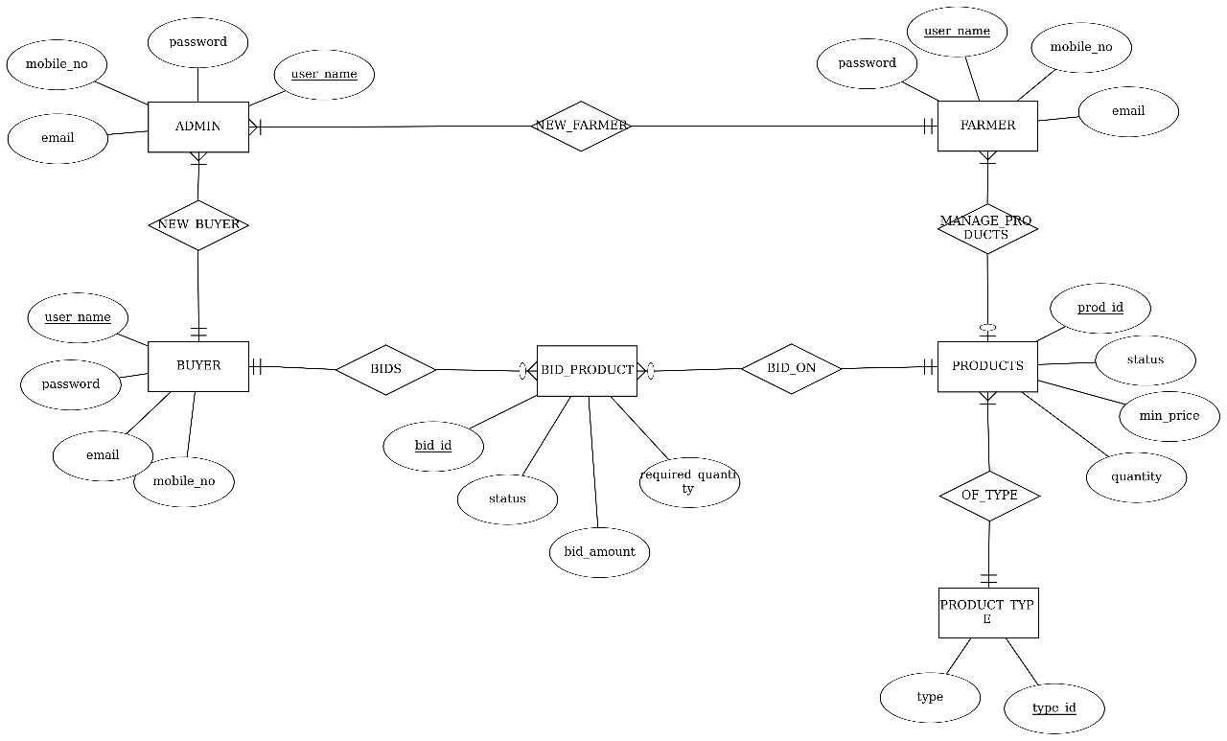

**RELATIONAL DATABASE DESIGN**

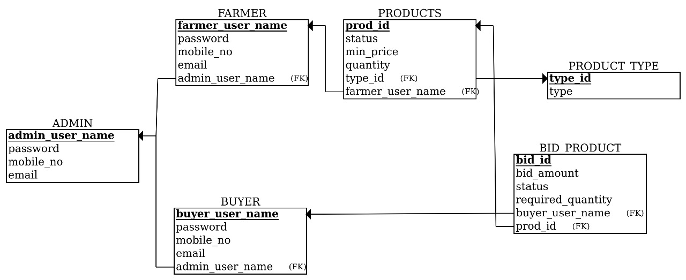

**DATABASE NORMALIZATION**

**DATA DIRECTORY**

**GRAPHICAL USER INTERFACE**

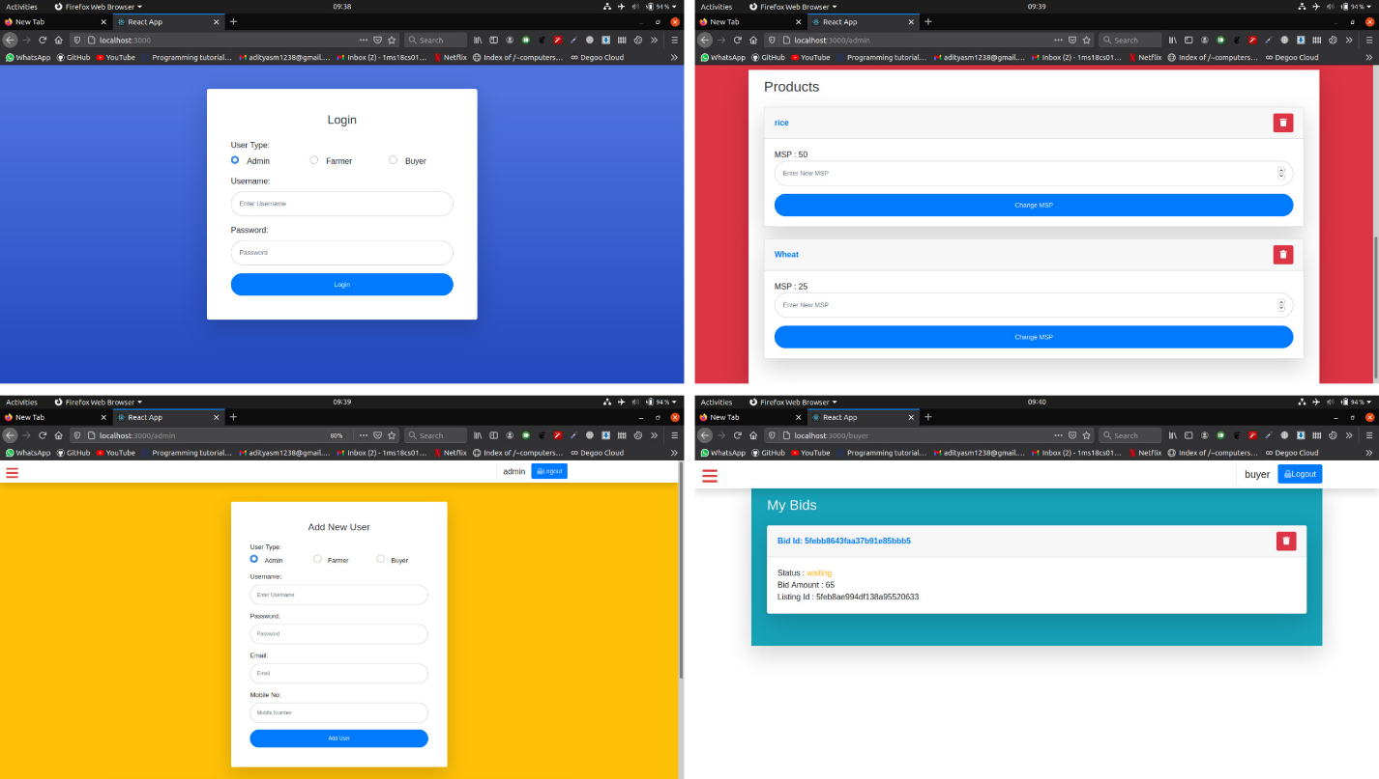

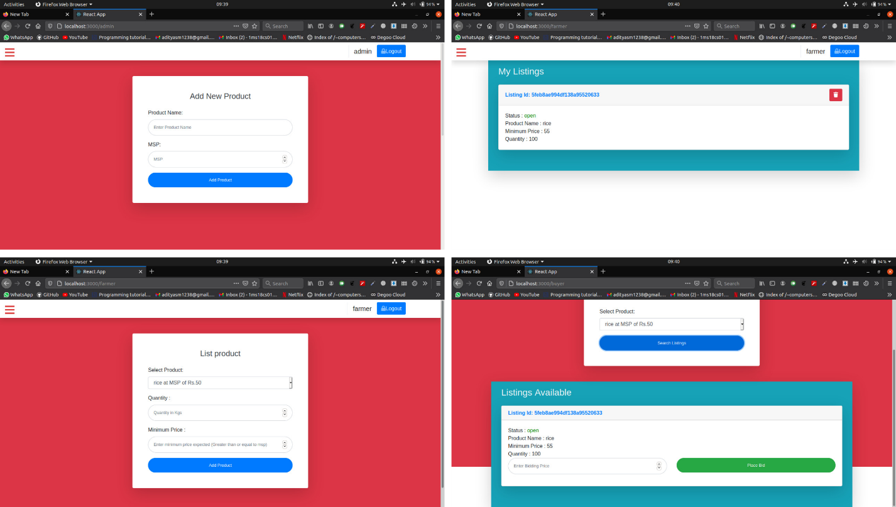

**SOURCE CODE**

**CONCLUSION**

The project is completely related to the farmers and the customers. It would benefit both of them equally. Farmers will get the complete price of their hard work. Customers need to pay only the price of the product and not the intermediate charges which are applied due to the involvement of the middlemen. This application completely eliminates middlemen hence it’s a direct communication platform between the farmers and the customers.

This web application not only provides the highest price for the farmers but also it possess many additional features which serve the application as the most easy, reliable and user friendly application which would in-turn help the users who are new to this computer era.